Follow the installation process in
Getting Started - Airbase Documentation
e.g type “curl -fsSL https://console.airbase.tech.gov.sg/dist/install.sh | sh” in windows powershell

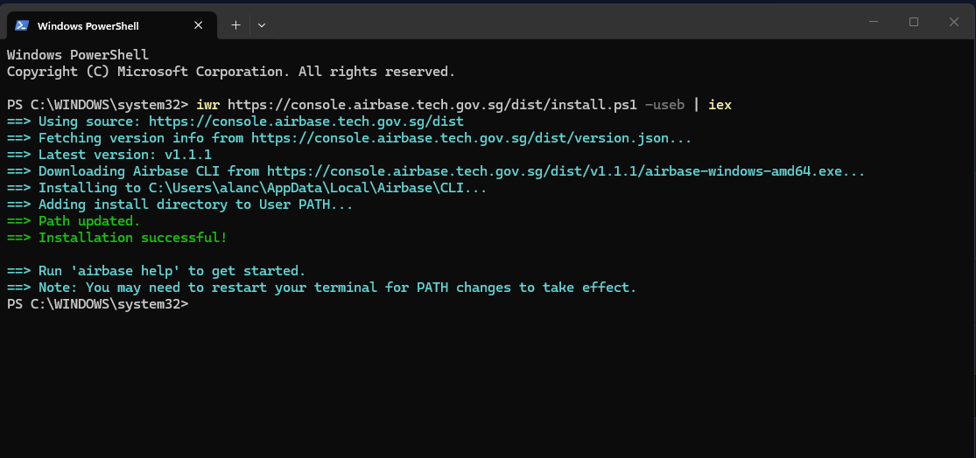

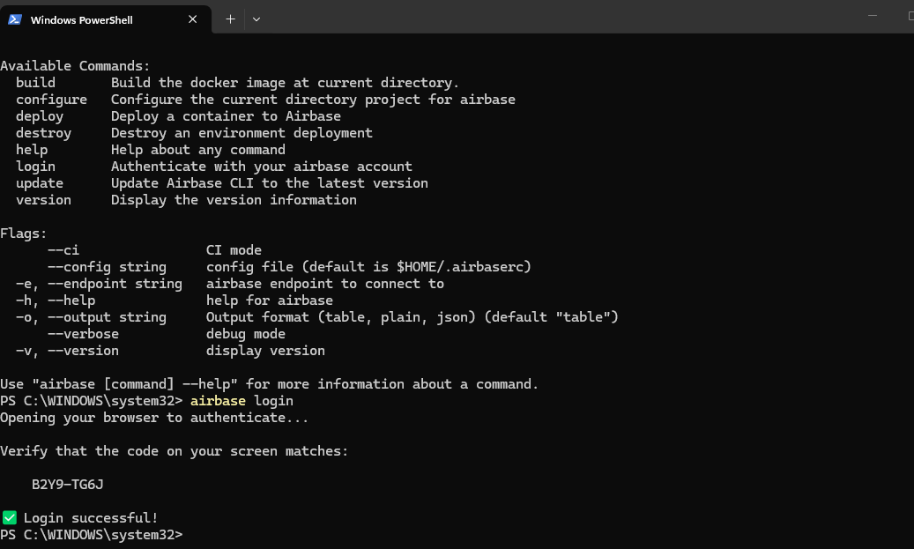
Check version
airbase --version
Visit the link with a web browser to complete the authentication process.
🛫 Log in to Airbase in your browser Visit: https://console.v2.airbase.sg/settings/credentials/cli?challenge=singleusetoken Press Ctrl + C to cancel ======= after filling in the form ======= ✅ Successfully logged in

Pull application image
Start by pulling the application image to be deployed
Airbase only supports linux/amd64 image. Take extra care to pull linux/amd64 image!
docker pull --platform linux/amd64 docker pull alanchow85/airbase:v3.0
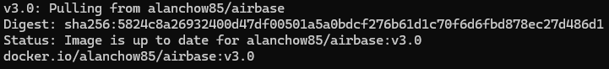

If you package locally, use push

Since you have authenticated and link to Airbase earlier use the command below to link to a environment you set up in Airbase
airbase configure

first create a team in Airbase with the create button below in Airbase | Welcome to Airbase
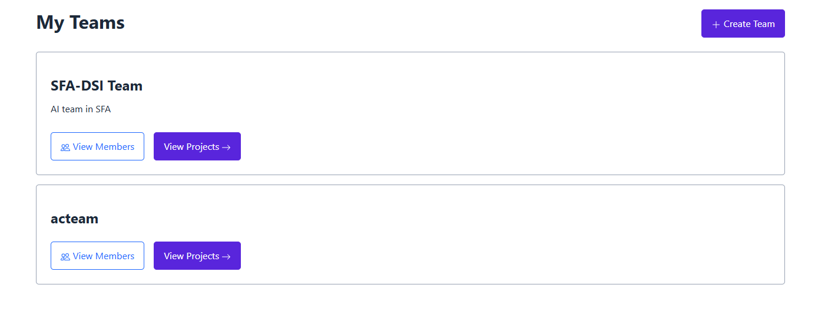
Click on create project to create a project instance
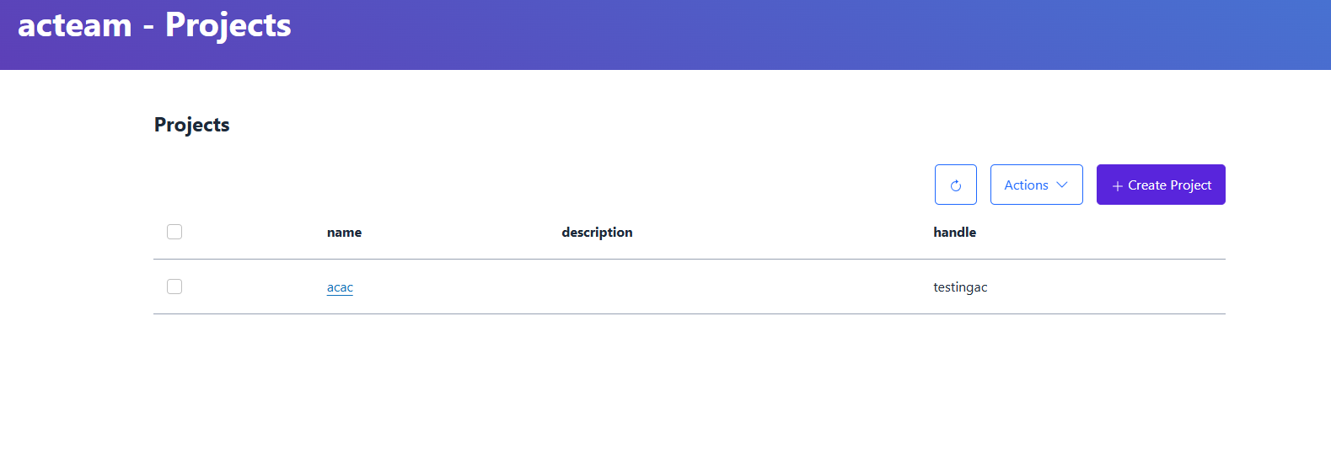
Fill in all details esp handle then click save
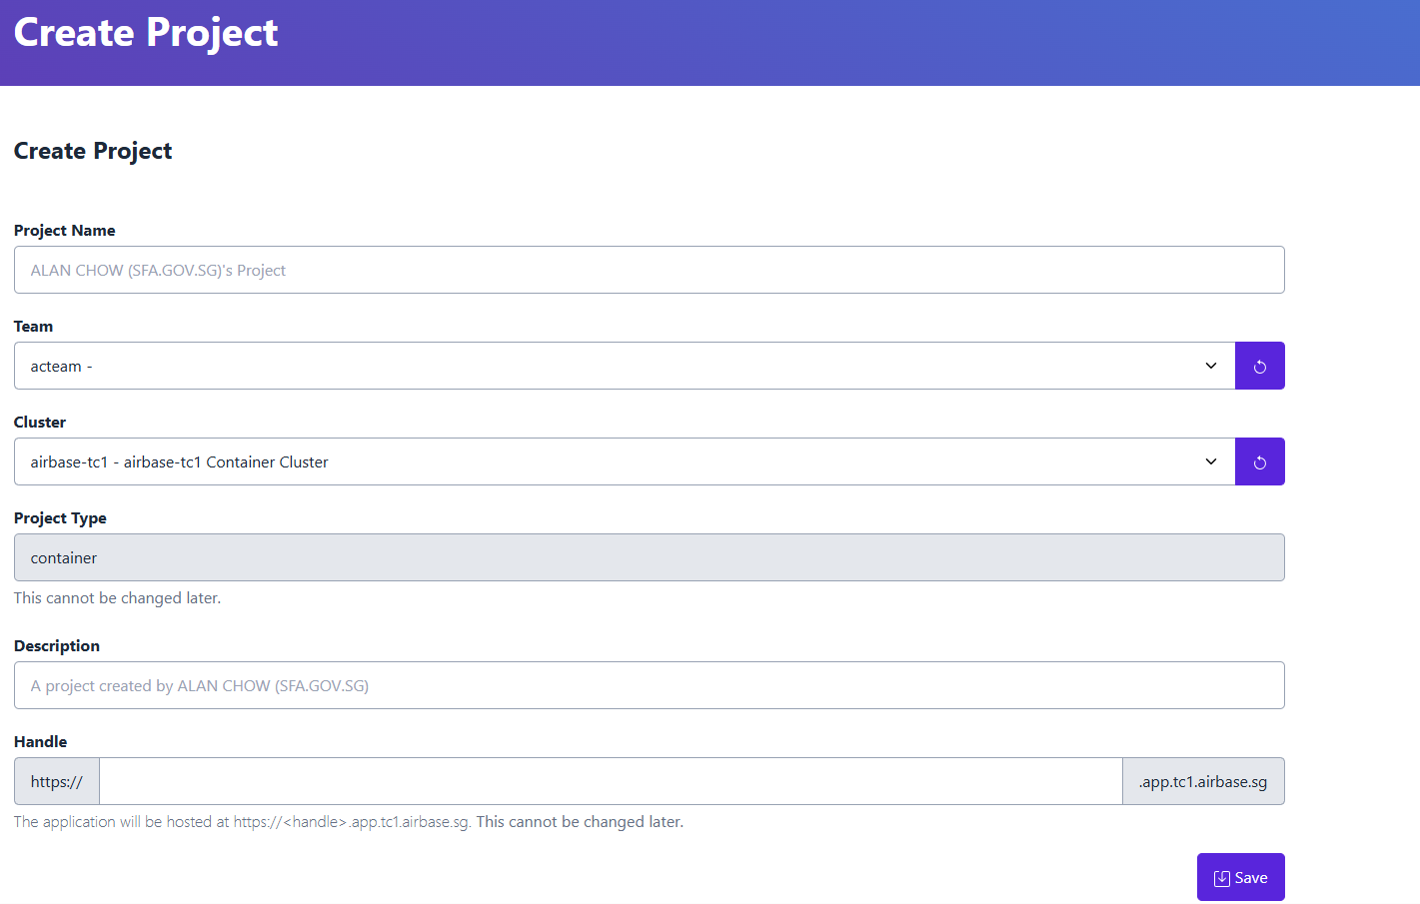

Last, use the command, airbase deploy

to deploy the image
airbase container deploy --image alanchow85/airbase:v3.0

And viola, it will be deploy. But please remember to map the port in the dockerfile to expose port 3000 for airbase server

